Date: MAY 31 2021 File: C:\Karapetyan\18501 Нержавейка на ПКС - в расчет\03_program\10\18501 Нержавейка 10001.NST

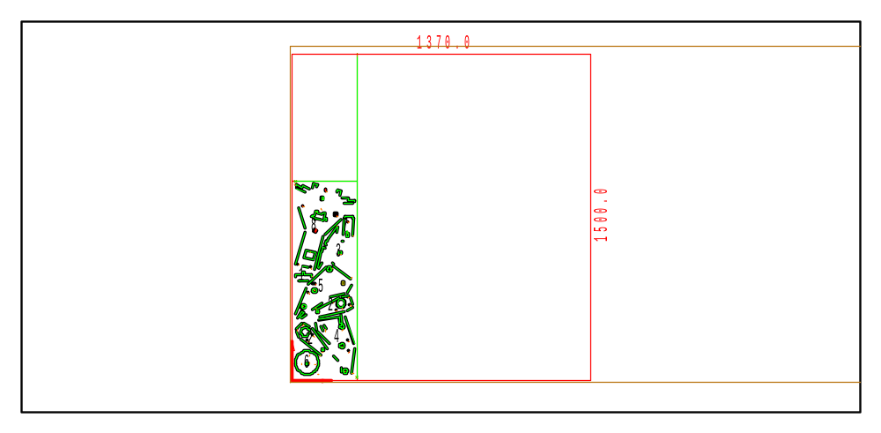

PART INFO
NC File Name: Ê!Å;Ä2RÅ1ÌÌÄ*ÌÅ1@ËÍ
Draft no.: | Version:
Order no.: | Description:
SHEET Number of sheets: 1
Material: Stainless | Sheet size: 1370 X 1500 | T= 10.0
No. of parts: 9 | Part size:
Part weight: | Sheet weight: 160.29 kg
MACHINE:
MODEL: ML3015EX |  | Con. name: SUS304B |  | Table name: ML45CF_R_EX
Gas: N2H | Lens: 7.5 Inches |  | Nozzle diameter: 1.5
Speed: 1100 |  | Used laser power: 4500 |  | Beam diameter (kerf): 0.4
PROGRAM
Number: 4170 | File size: 15003 | Programmer:
Notes:
JOB TIME (min:sec)
Travel: 00:18 | Cut: 09:38 | Pierce: 15:59
Travel way: 7589.5 mm | Cutting way: 0 mm | Pierce Qty.: 50
Total time: 25:55

 | Part name | DX | DY | QTY
3 | Ê#Å;32.70.04.01.041-20ÌÌÌ_Ì-ËÍ | 171.9 | 188.8 | 1
8 | Ê#Å;32.70.06.02.006-_ÌzËÍ | 272.2 | 405.9 | 1
4 | Ê#Å;32.70.04.01.042-10ÌÌ_ÌSËÍ | 178.1 | 287.5 | 1
7 | Ê#Å;32.70.06.02.005-_ÌhËÍ | 51.4 | 108.2 | 1
2 | Ê#Å;32.70.04.01.032-20Ì_Ì~ËÍ | 178.5 | 97.5 | 2
5 | Ê#Å;32.70.04.01.043-10ÌÌ_ÌeËÍ | 261.7 | 244 | 1
6 | Ê#Å;32.70.04.14.001-_Ì3ËÍ | 120 | 120 | 1
1 | Ê#Å;32.70.04.01.023-_ÌBËÍ | 70 | 37 | 1

